## Methodology Identifying 2018 Waterloo-affiliated OA output in Web of Science

Data sources  
Web of Science  
InCites

Date of searching  
May 30, 2019

Search strategy

1. Identify 2018 Waterloo-affiliated publications in Web of Science

Organization: University of Waterloo 🡪 Publication date: 2018 🡪 4,044 results

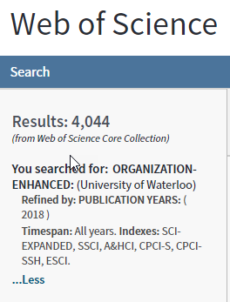

1. Within the WoS results, identify publications identified as OA & export results to InCites  
     
   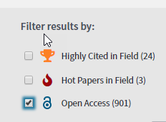  
   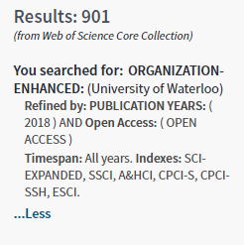  
   Filter results by: Open Access 🡪 901 results (WoS) 🡪 exported to InCites as this dataset: “Waterloo 2018 OA output May 30 2019” **🡪** 752 results (InCites) 🡪 saved as: *OA 2018 WoS.csv*
2. Within the same WoS results, identify the OA Publications identified as “Other Gold” & export results to InCites

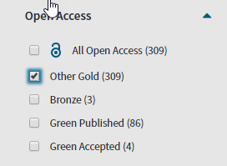

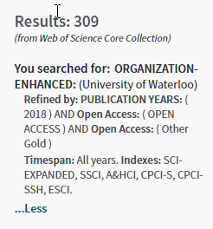

“View all options” 🡪 Open Access 🡪 Other Gold 🡪 309 results (WoS) 🡪 Exported to InCites as this dataset: “Waterloo 2018 other gold output May 30 2019” 🡪 255 🡪 saved as: *OA other gold 2018 WoS.csv*

|  |  |
| --- | --- |
| **Data source** | **What data does the OA filter include?** |
| Web of Science | [Open Access](https://images.webofknowledge.com/images/help/WOS/hp_whatsnew_wos.html): Includes all OA (gold/green/bronze); can export into InCites as a custom dataset. “In 2014 we invented OA discovery, and in 2017 we partnered with Impactstory to provide better identification of Open Access publications already indexed in the Web of Science, and now, in 2018 we extended our offering to include legal peer-reviewed Green and previously hidden Hybrid Gold.” (source: [OA on Web of Science](https://clarivate.com/products/web-of-science/open-access)). From Clarivate: “Just take note that Bronze OA fluctuates as it is promotional and temporary decisions by publishers and no set time or patterns can be taken into consideration.” More information: [OA Fact Sheet](https://clarivate.com/wp-content/uploads/2018/10/WOS_Open-Access_OCT-Update-FINAL-1.pdf), and [OA content in Web of Science (video)](https://www.youtube.com/watch?time_continue=60&v=F98qREBOr7M)  [Other Gold](https://images.webofknowledge.com/images/help/WOS/hp_whatsnew_wos.html): “Most of these articles are from hybrid journals. Hybrid open access journals are subscription journals that include some open access articles. Keep in mind, identification of Other Gold as an indicator of Hybrid Gold open access articles is at varying levels of completeness, especially for newly published items.” Therefore is useful as a proxy but is not perfect. |